T-Mobile IP Relay
Two-Line Hearing Carry-Over
T-Mobile IP Relay’s Two-Line Hearing Carry-Over allows a person with a speech disability to listen and type their conversation while the Relay Operator reads aloud to the other party.

How does Two-Line Hearing Carry-Over (HCO) work?
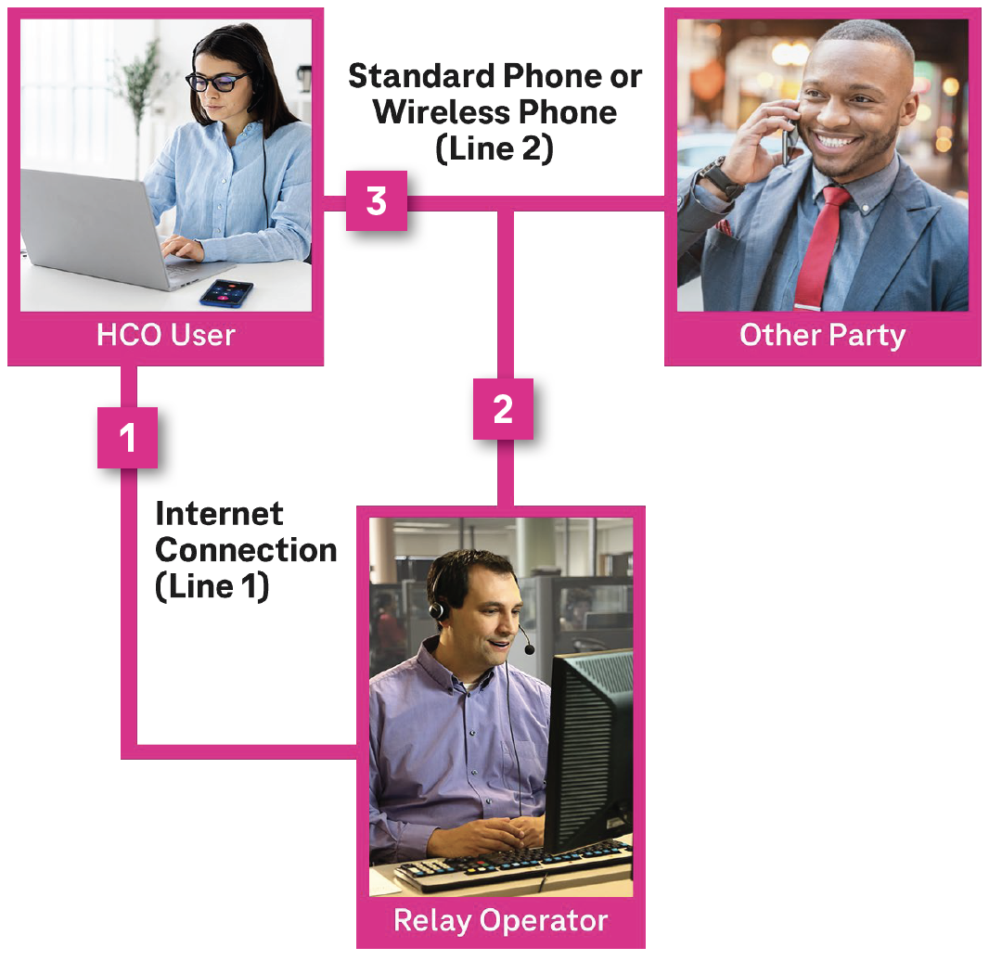
- On Internet connection (Line 1), the HCO user types their conversation for the Relay Operator to read to the other party.
- On the phone connection (Line 2), the Relay Operator reads the HCO user’s typed message to the other party.
- The HCO user listens to the other party response using Line 2 (phone connection).
NOTE: The HCO user can listen to the other party while typing at the same time.

Technical Requirements:
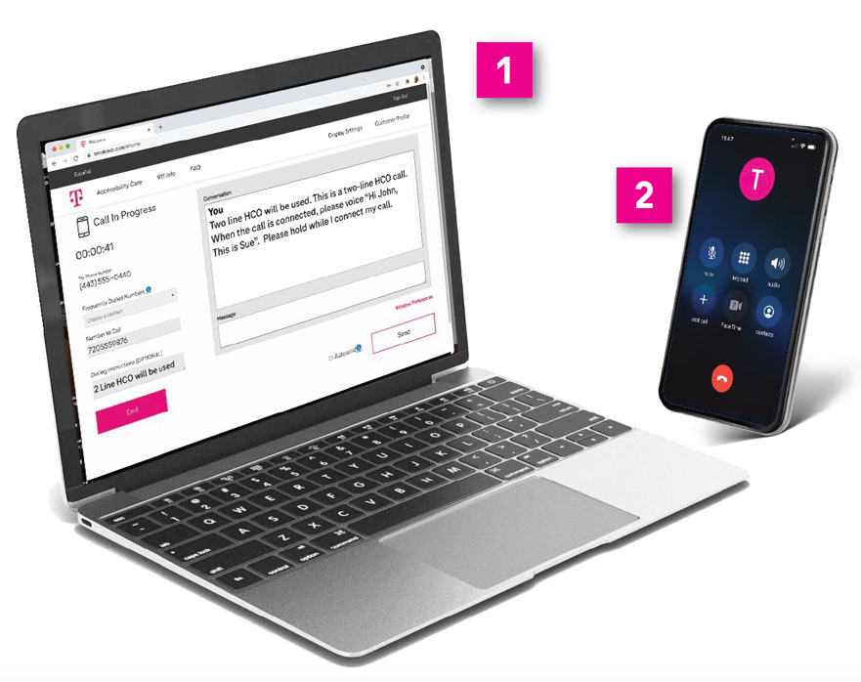
- An Internet connection (Line 1) is for a personal computer, laptop or tablet.

- A standard phone with three-way calling OR a wireless phone with the “add call” feature (Line 2).
The Internet and telephone connections allow the HCO user to hear everything and the Relay Operator to read the HCO user’s typed conversation to the other party.

Instructions to make a Two-Line Hearing Carry-Over (HCO) call:
Go to t-mobile.com/iprelay
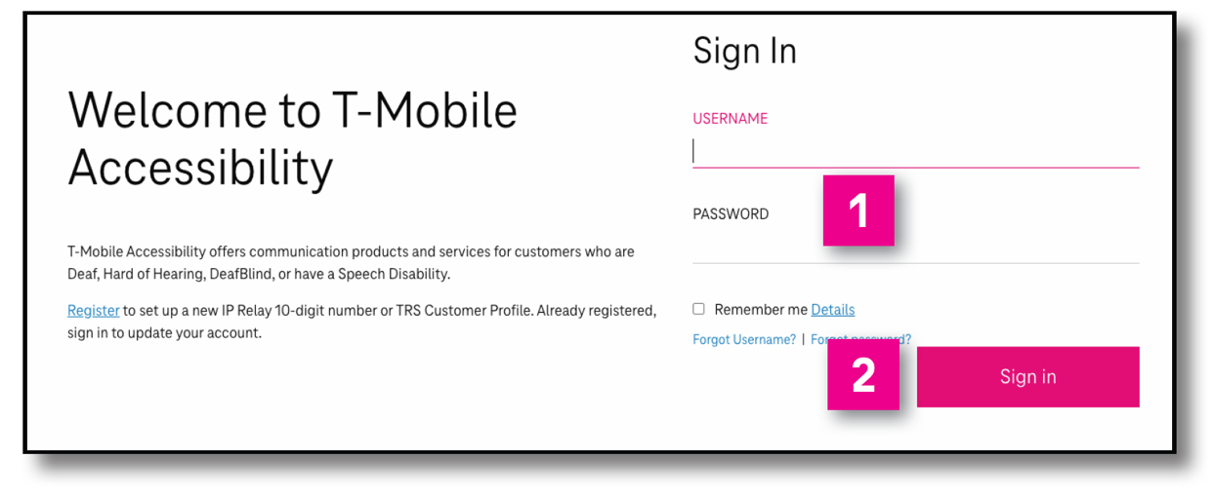
- Type your username and password.
- Click to Sign in.
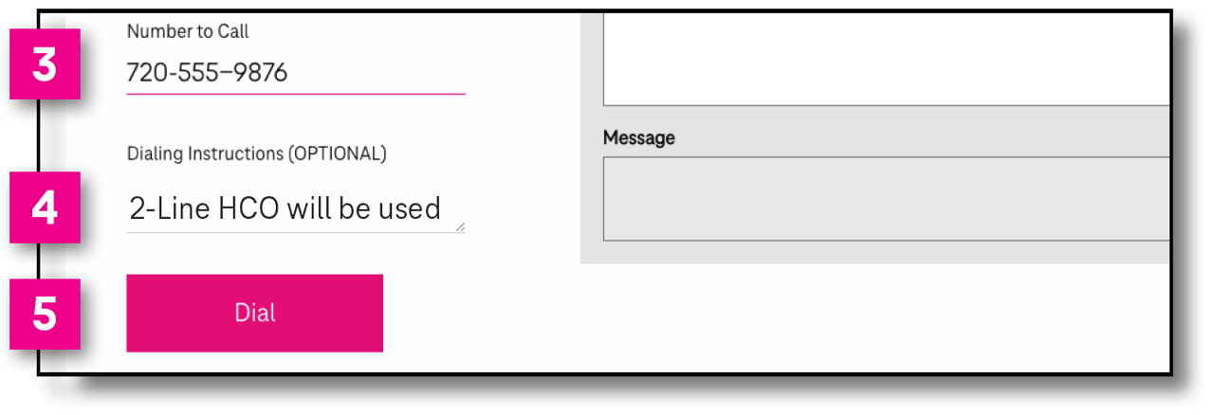
- Number to Dial: Enter your standard or wireless phone number.
- Dialing Instructions: Type 2 -Line HCO will be used.
- Click Dial.
The Relay Operator will call your standard or wireless phone number (Line 2).
- Type to the Relay Operator your announcement or greeting to the other party you are calling.
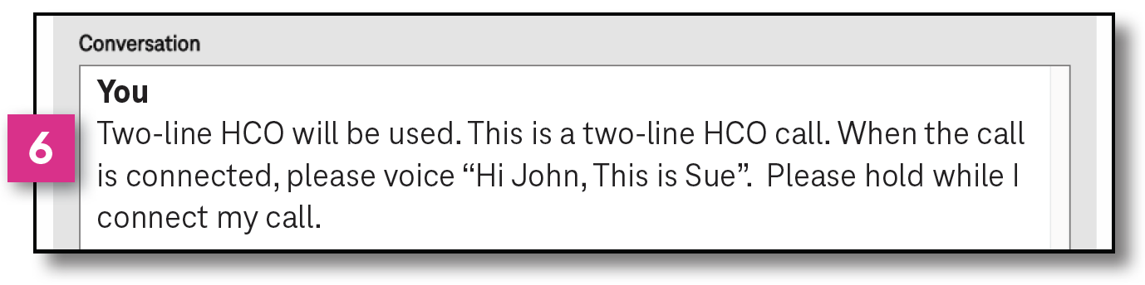

How to bridge the other party and Relay Operator:
- For wireless phone:
Tap Add Call and enter the phone number
you want to call.
For standard phone:
Follow three-way calling feature instructions provided by your telephone service provider.
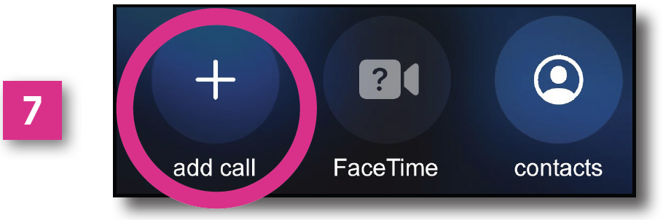
- When the other party answers, tap Merge or Merge Calls to reconnect with the Relay Operator to begin your 2-Line HCO call.
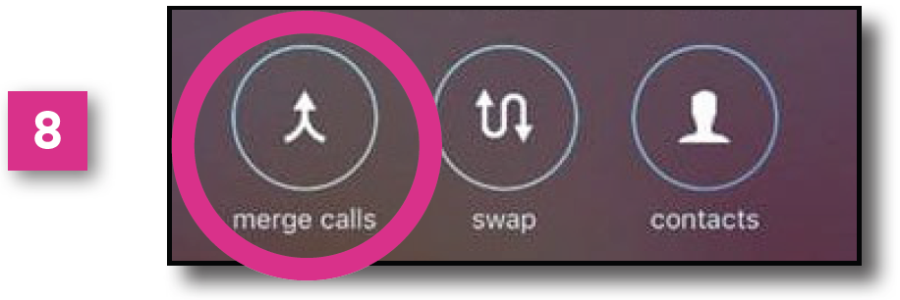
- Begin your conversation. The Relay Operator will voice your greeting and you will hear everything spoken.
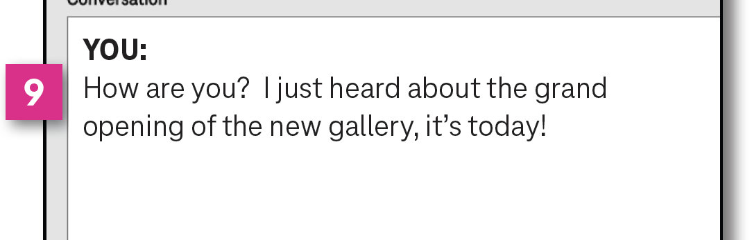

Registration is required.
Visit t-mobile.com/iprelay to set up a new IP Relay 10-digit number.

T-Mobile Accessibility Care Contact Information
Voice/TTY: (800) 676-3777
Speech-to-Speech: (877) 787-1989
Español: (800) 676-4290
Email: iprelay@t-mobile.com
Fax: (877) 877-3291
Websites:
t-mobile.com/iprelay
tmobileaccess.com/iprelayinfo

Although IP Relay can be used for emergency calling, such emergency calling may not function the same as traditional 911/E911 svc. By using IP Relay for emergency calling, you agree that T-Mobile is not responsible for any damages resulting from errors, defects, malfunctions, interruptions, or failures in accessing or attempting to access emergency service through IP Relay whether caused by the negligence of T-Mobile or otherwise. Registration and Internet connection required. Devices and screen images simulated. Restrictions apply. See t-mobile.com/access for details. T-Mobile, the T logo, Magenta and the magenta color are registered trademarks of Deutsche Telekom AG. © 2022 T-Mobile USA, Inc.

