T-Mobile IP Relay App for Android-based phones and tablets

Overview of T-Mobile IP Relay App's Main Screen
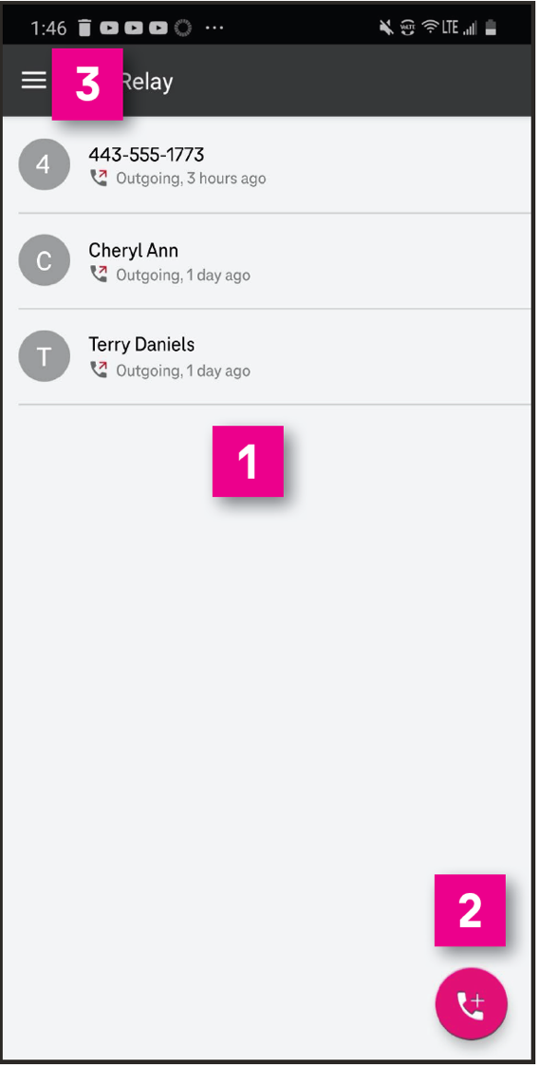
- Call History:
List of your call history log, including outgoing and incoming calls. Tap phone number or name to make the relay call.
- Phone Icon: Tap the phone icon to make relay calls.
- Menu: Tap the Menu icon to go to the Menu page.
(See #4 through #8 below)
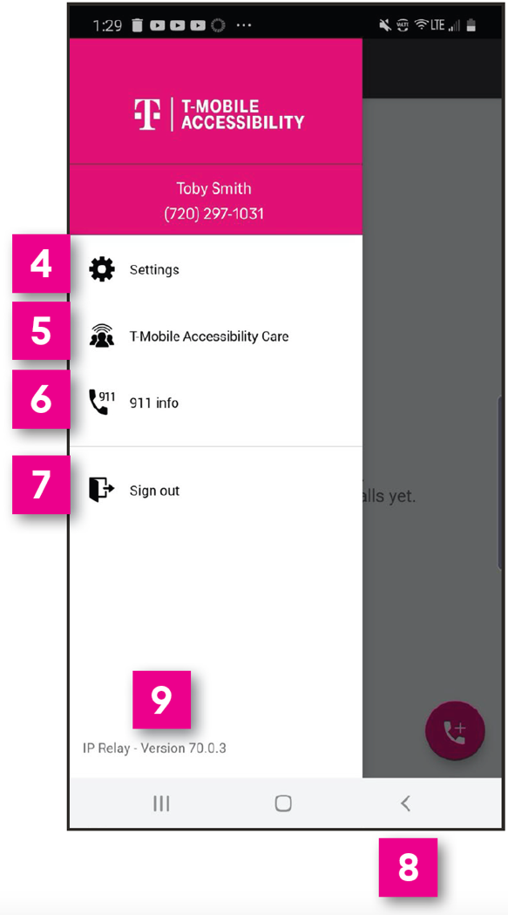
- Settings: Change a password, text size and color, background color, select language (English and Spanish), and clear conversation history.
- T-Mobile Accessibility Care: Make a call to T-Mobile Accessibility Care. Sign-in required.
- 911 Info: Provides 911 information for all T-Mobile Accessibility products and services.
- Sign Out: Sign out T-Mobile IP Relay app. *
* NOTE: You must be signed in to make and receive IP Relay calls.
- Close Menu: Tap to close the Menu page.
- Check for periodic updates to the app.

How to Get IP Relay Mobile App
- Go to Google Play and search for T-Mobile IP Relay.
- Download the T-Mobile IP Relay app.

Sign In Screen
- Username & Password: Type your username and password. To create a username and password.
(see #6 and #8 for details.)
- Remember Me: If you wish to login without
re-typing your password, turn on Remember Me.
- Forgot username/password: Tap to get your username or re-create a new password.
- Register for IP Relay: For a first-time IP Relay user, tap to register.
- Contact Support:
Send email to T-Mobile Accessibility Care.
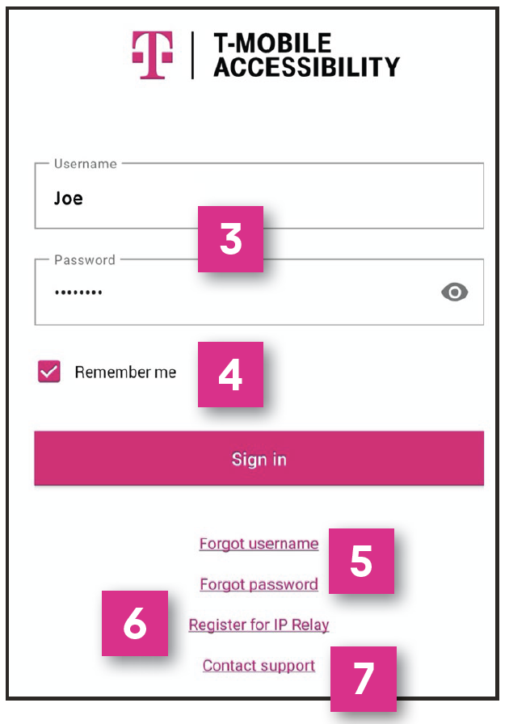
- Register for an IP Relay number by:
- providing your information,
- choosing a security question/answer,
- creating a username and password
- and reading legal disclaimers.
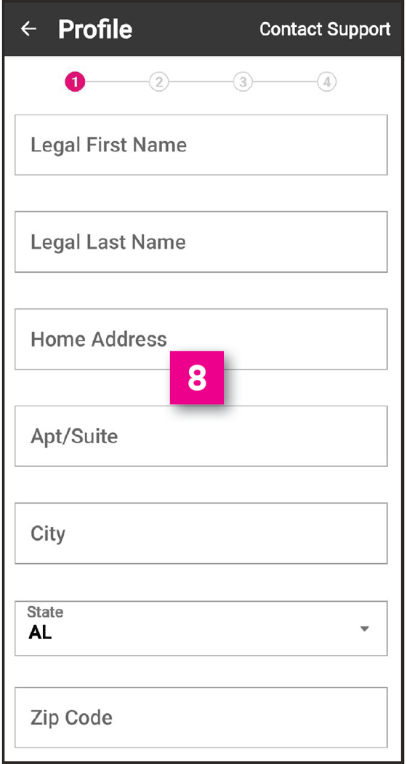

To complete registration, contact T-Mobile Accessibility Care:
- iprelay@t-mobile.com (Email)
- (800) 676-3777 (Voice/TTY)
- (800) 676-4290 (Español)
- (877) 787-1989 (Speech-to-Speech)

How to Make a Call
On the Call screen, two options are available to make relay calls.
OPTION 1:
- Tap the phone icon on the lower right.
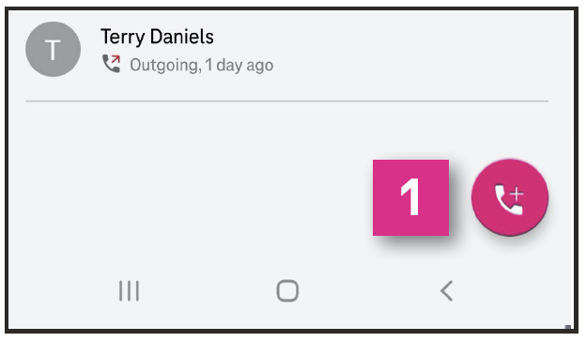
- Type the name or phone number of the person you wish to call using your Contacts from your phone.
Note: Permission must be granted to access phone Contacts when app is installed.
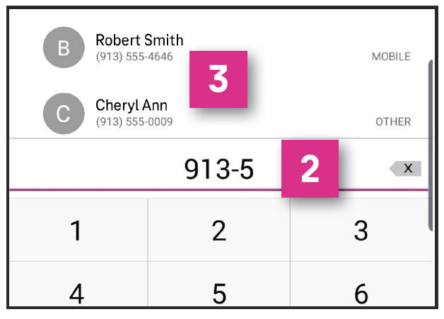
- Tap the name or number to make a call.

OPTION 2:
- Tap name or phone number on the Call History Log.
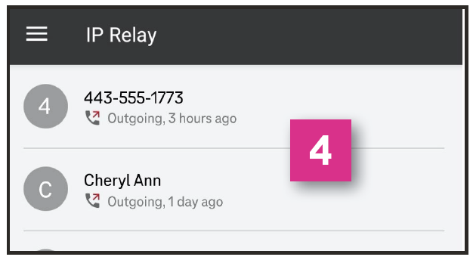
- Tap Call to make a call.
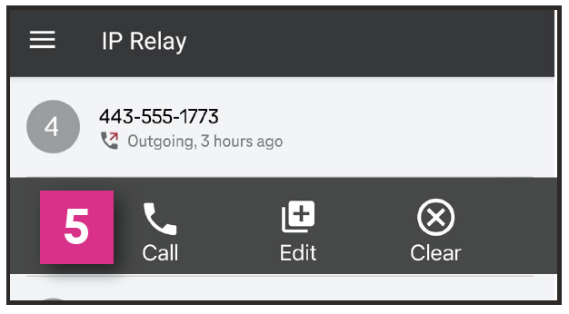

Call in Progress
- When your call is connected, you may begin your conversation.
- Tap the arrow button to send your message.
NOTE: Your conversation is on the right side and your caller's conversation is on the left side of the screen.
- Tap End to end conversation.
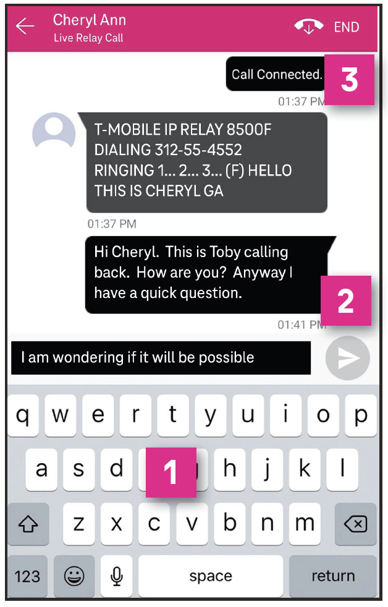

Call Disconnected
- Done: Closes the conversation screen and deletes the call transcript.
- Copy: Copy and paste your call transcript in a document (i.e., Microsoft Word or Notepad).
- Email: Email your call transcript to yourself.
- Cancel: Closes the Transcript Options.
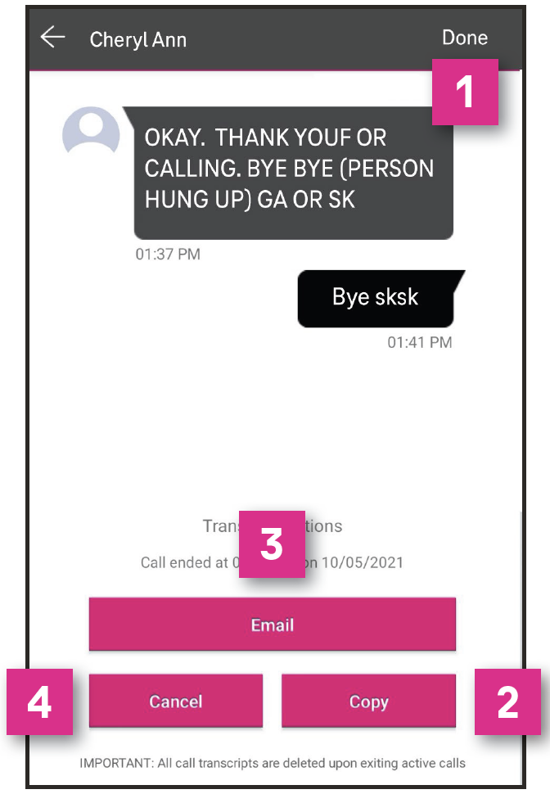

Accessibility Settings
- On your smartphone's screen, tap Settings.
- Scroll up and tap Accessibility.
- Scroll up and tap Visibility enhancements.
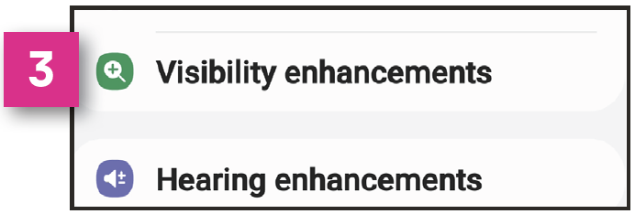
- Options may be supported by the IP Relay that best support the IP Relay users needs as follows:
- High contrast fonts
- Highlight keyboard
- highlight buttons
- Color inversion
- Magnifier window
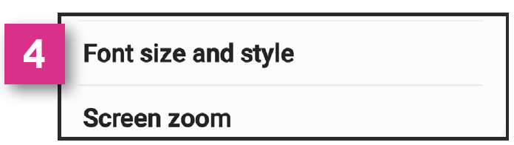
- Scroll up and tap Font Size and style that includes:
- Font style
- Bold font
- Font size
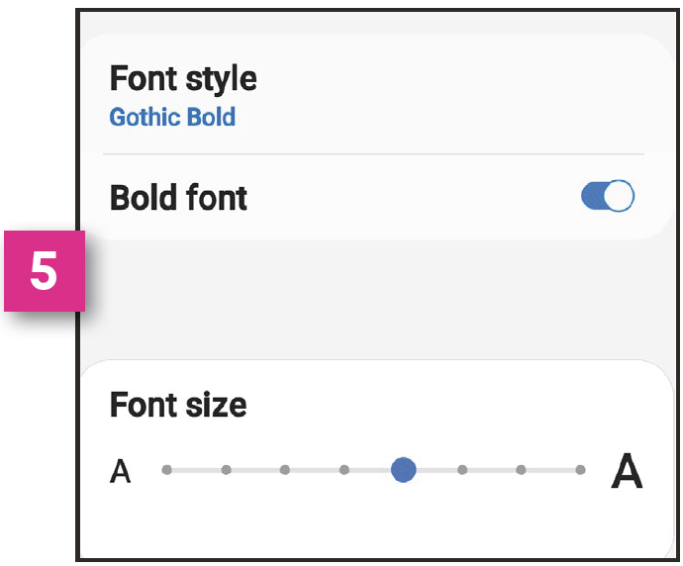

IP Relay Settings
- Tap the Menu icon.
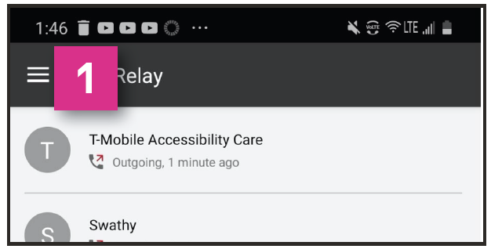
- Tap Settings.
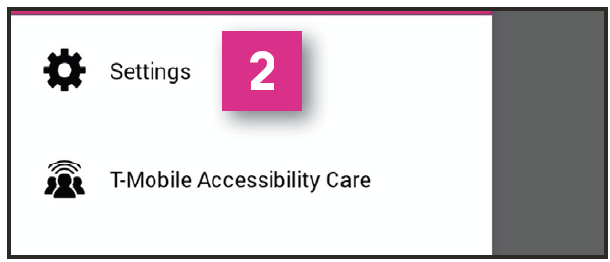
- Change Password:
Update or change your password.
- Conversation Style:
Adjust text size, color and set up accessibility for a Braille user. See #6 through #9 below.
- Clear History: Clears all call history.
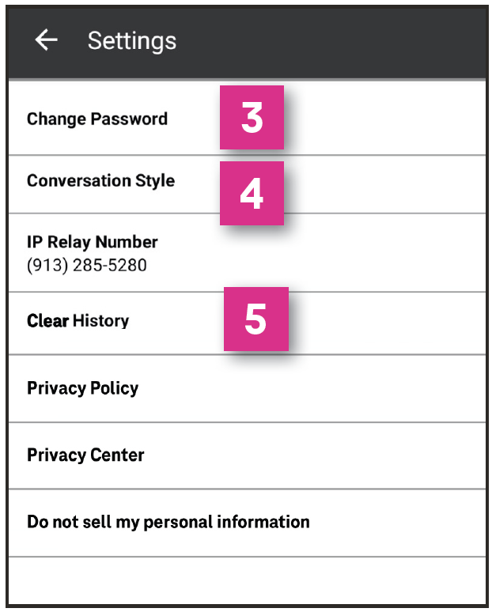
Conversation Style
- Conversation Contrast: Set text and/or background to light or dark of your choice.
- Language: Set the language preferences for the Relay Operator as English or Spanish. Spanish-to-English/English-to-Spanish translation is not allowed.
- Are you a Braille user?: Select Yes or No if you are using a Braille display. This is an ideal feature for DeafBlind braille users.
- Choose Braille display text speed to either slow or standard. Relay Operator also has the ability to increase or decrease transmission speed during a call.
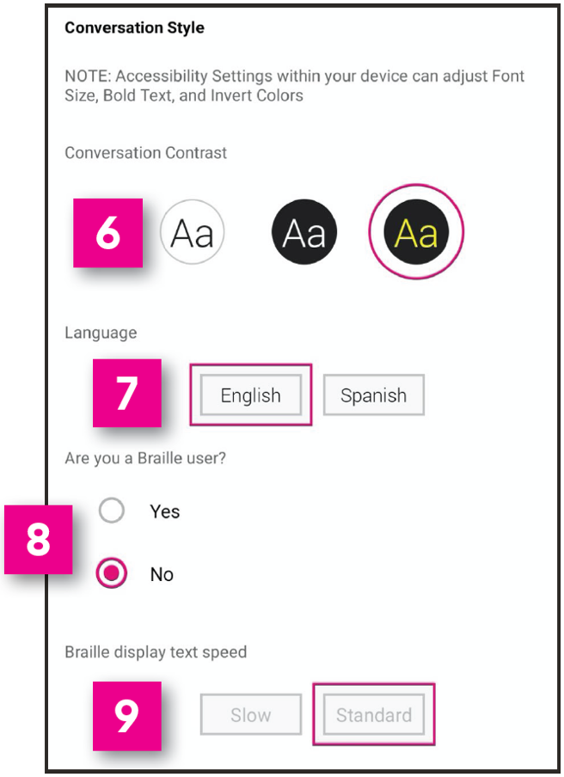

How to get into your Customer Profile
- Go to t-mobile.com/iprelay.
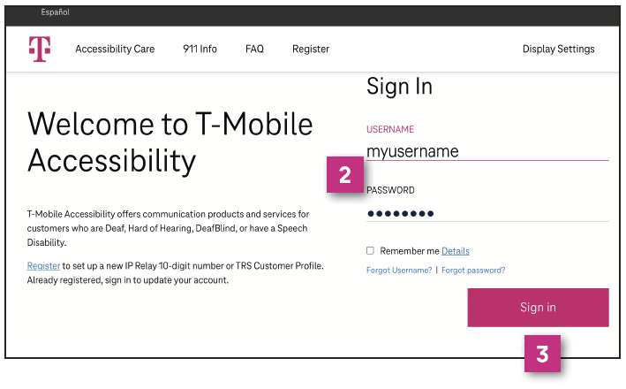
- Sign in with your username and password.
- Click Sign in.
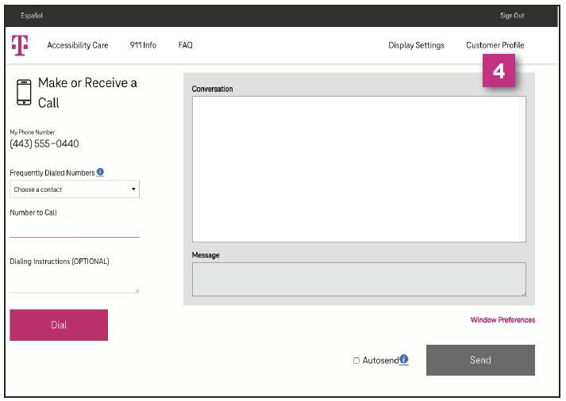
- Click Customer Profile on the upper right corner of the IP Relay screen.

Your Customer Profile
- IP Relay Numbers: Allows IP Relay users to request, port or delete IP Relay numbers.
- Emergency Location: Important for IP Relay users to provide their location(s) for emergency services.
- Frequently Dialed: Allows IP Relay, TRS and Speech-to-Speech callers to store up to 100 frequently dials numbers.
- Call Preferences: Allows TRS and IP Relay callers to select: Gender, Language for Incoming Calls, Answer type defaults to Voice and Call Handling.
- Notes: Allows TRS and IP Relay users to include brief notes for the Relay Operator.
- Speech to Speech: Options available for Speech-to-Speech users.
- Emergency Numbers: Allows users to save preferred emergency numbers (i.e., doctor, attorney, etc.)
- Permissions: Options for blocking types of outbound calls.
- Personal Information: Update address information.
- Account Security: Change Password or Security
Question/Answer.
- Print: Print your Customer Profile information.
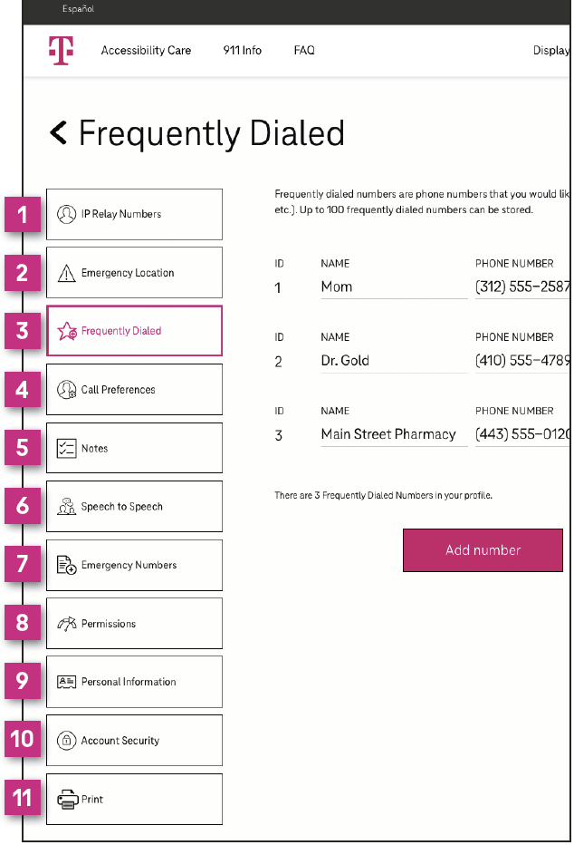

T-Mobile Accessibility Care Contact Information
- Voice/TTY: (800) 676-3777
- Speech-to-Speech: (877) 787-198
- Español: (800) 676-4290
- Email: iprelay@t-mobile.com
- Fax: (877) 877-3291
- Websites:
t-mobile.com/iprelay
tmobileaccess.com/iprelay

* Registration and Internet connection required.
Although IP Relay can be used for emergency calling, such emergency calling may not function the same as traditional 911/E911 svcs. T-Mobile is not responsible for any damages resulting from errors, defects, malfunctions, interruptions, or failures in accessing or attempting to access emergency savcs through IP Relay. Devices and screen images simulated. T-Mobile, the T Logo, Magenta and the magenta color are registered trademarks of Deutsche Telekom AG. ©2022 T-Mobile USA, Inc. All other marks are property of their respective owner.

