T-Mobile IP Relay
t-mobile.com/iprelay
Overview IP Relay Homepage
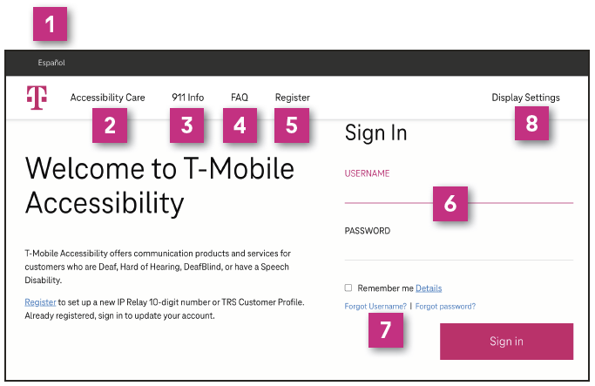
- Español: Click Español to switch the website to Spanish, click Customer Profile, and then click Call Preferences and Incoming Calls to Español.
English-to-Spanish or Spanish-to-English translation services are not allowed.
- Accessibility Care: Sign in to make a call to Accessibility Care directly
- 911 Info: Provides 911 information for Accessibility products and services.
- FAQ: Frequently Asked Questions.
- Register: Sign up to get an IP Relay phone number.
NOTE: You must register first before using IP Relay.
- Sign In: Click “Remember me” to stay signed in to make and receive IP Relay.
- Forgot Username or Password: Click to get your username or password to reset
- Display Settings: Adjust font sizes and contrast.
NOTE: You must be signed in to make and receive incoming IP Relay calls.

How to Register
- Go to t-mobile.com/iprelay.
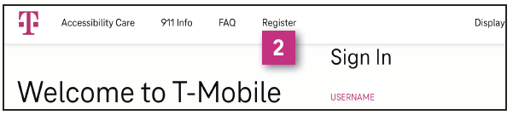
- Register: To register for an IP Relay number.
NOTE: State Telecommunications Relay Service (TRS) users also have the option to create a Customer Profile.
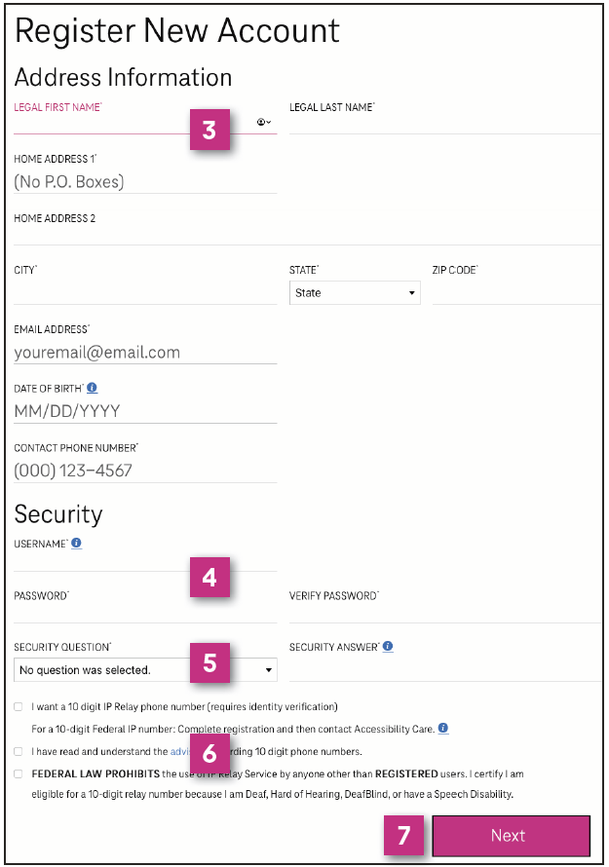
- Address Information: Type your legal full name, home address, email address, date of birth and phone number.
- Security: Create your username and password.
- Security Question: If you forget your password, the security question will be sent in order to reset password. Select your security question and type your answer.
- Read and Check:
“I want an IP Relay phone number.”
“I have read and understand the advisory regarding digit phone numbers.”
“FEDERAL LAW PROHIBITS the use of IP Relay Service by anyone other than REGISTERED users. I certify I am eligible for a 10-digit relay number because I am Deaf, Hard of Hearing, DeafBlind, or have a Speech Disability.”
- Click Next.
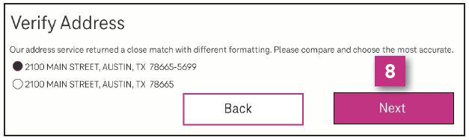
- Verify Address: Verify an address to ensure your address is correct. Click Next.
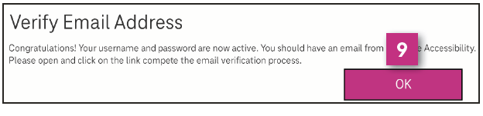
- Verify Email Address: Verify an email address to ensure your email address is correct. Click OK.
Contact Accessibility Care to complete registration or if verification fails:
- iprelay@t-mobile.com (Email)
- (800) 676-3777 (Voice/TTY)
- (800) 676-4290 (Español)
- (877) 787-1989 (Speech-to-Speech)

How to Sign In
- Go to t-mobile.com/iprelay.
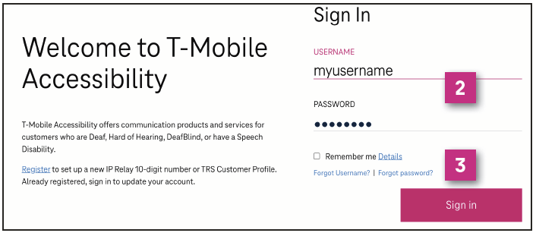
- Sign in with your username and password.
- Click Sign in.

Magnify Conversation Screen
This is an ideal feature for users who have low vision or DeafBlind.
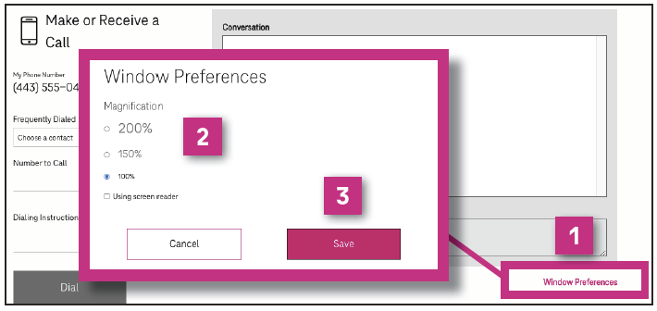
- Click Window Preferences.
- Select magnification for the conservation screen by 100%, 150% or 200%.
- Click Save.

How to Make a Call
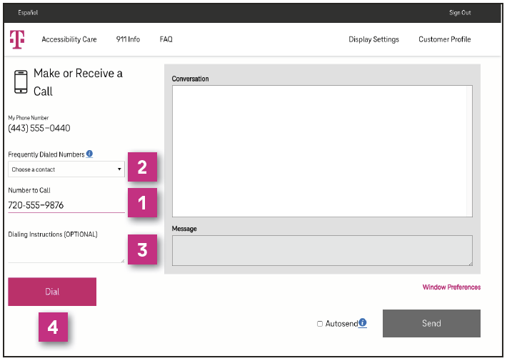
- Enter the telephone number you wish to call.
or
- Select a phone number from a Frequently Dialed Numbers contact list*
NOTE: To add contacts, click Customer Profile and click Frequently Dialed.
- Dialing Instructions (Optional): Type a short message to the relay operator. For example; "if answering machine please hang up," "don't announce relay service," "ask for Mark," etc.
- Click Dial.

Call in Progress
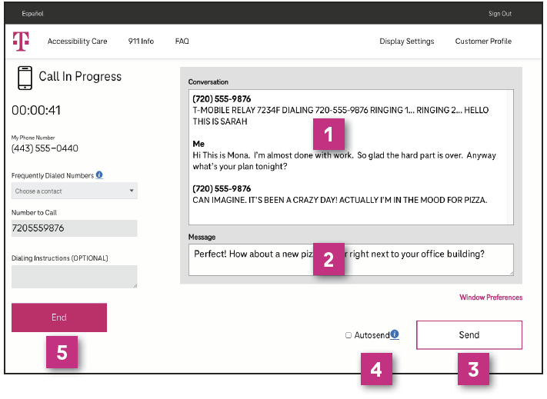
- Conversation screen.
- Type your message in the dialog box. This message will not be visible to the relay operator.
- Send your message, which will appear on screen.
- Turn Autosend on if you prefer to send your message upon pressing the space bar key on your keyboard.
- Click to end your phone call.

Call Disconnected
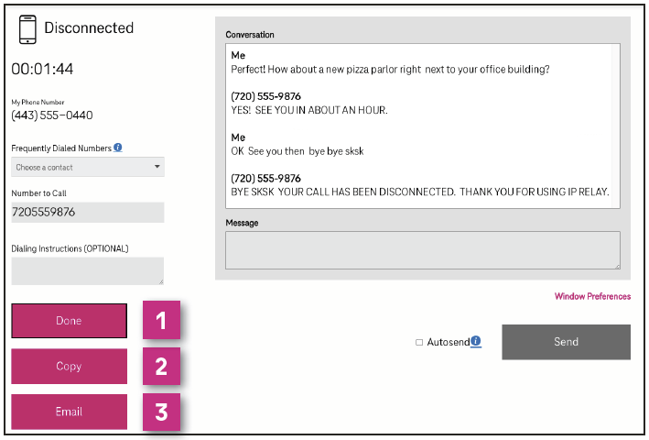
- Click Done to close the conversation screen and delete transcript.
- Click Copy to paste conversation transcript in document such as Microsoft Word or Notepad application.
- Click Email to email your conversation transcript to yourself or someone else.
How to get into your Customer Profile
- Go to t-mobile.com/iprelay.
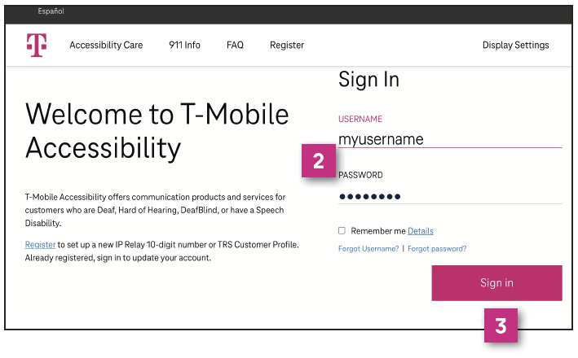
- Sign in with your username and password.
- Click Sign in.
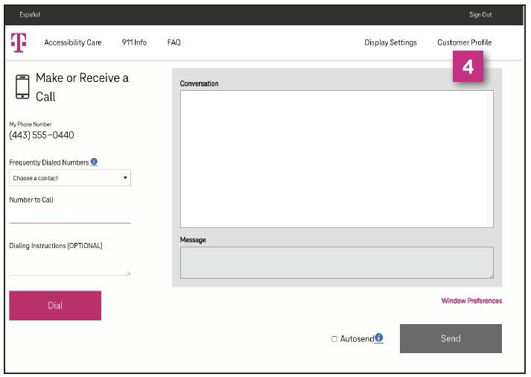
- Click Customer Profile on the upper right corner of the IP Relay screen.

Your Customer Profile
- IP Relay Numbers: Allows IP Relay users to request, port or delete IP Relay numbers.
- Emergency Location: Important for IP Relay users to provide their location(s) for emergency services.
- Frequently Dialed: Allows IP Relay, TRS and Speech-to-Speech callers to store up to 100 frequently dials numbers.
- Call Preferences: Allows TRS and IP Relay callers to select: Gender, Language for Incoming Calls, Answer type defaults to Voice and Call Handling.
- Notes: Allows TRS and IP Relay users to include brief notes for the Relay Operator.
- Speech to Speech: Options available for Speech-to-Speech users.
- Emergency Numbers: Allows users to save preferred emergency numbers (i.e.; doctor, attorney, etc.)
- Permissions: Options for blocking types of outbound calls.
- Personal Information: Update address information.
- Account Security: Change Password or Security
Question/Answer.
- Print: Print your Customer Profile information.

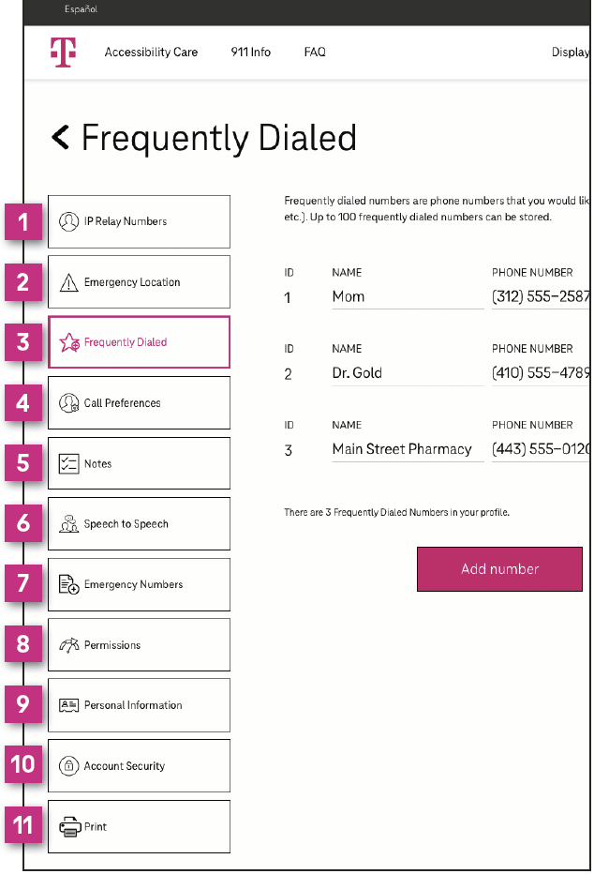

Accessibility Care Contact Information
Voice/TTY: (800) 676-3777
Speech-to-Speech: (877) 787-1989
Español: (800) 676-4290
Email: iprelay@t-mobile.com
Fax: (877) 877-3291
Website: t-mobile.com/iprelay

* Registration and Internet connection required.
Although IP Relay can be used for emergency calling, such emergency calling may not function the same as traditional 911/E911 svcs. T-Mobile is not responsible for any damages resulting from errors, defects, malfunctions, interruptions, or failures in accessing or attempting to access emergency savcs through IP Relay. Devices and screen images simulated. T-Mobile, the T Logo, Magenta and the magenta color are registered trademarks of Deutsche Telekom AG. ©2022 T-Mobile USA, Inc. All other marks are property of their respective owner.

